Materials Polymers
  - Key Revision Facts: GCSE Technology

Thermoforming
Thermoforming polymers are pliable, recyclable, and can be heated and formed repeatedly.
Name | Characteristics | Image | Example Use | Appearance | Recyclable
Acrylic (PMMA) | Tough plastic, easy to shape, and a great alternative to the high cost and less resilient glass |  | Greenhouses, car windows, smartphone screens, aquariums | Transparent, available in lots of colors | PMMA is 100% recyclable
High Impact Polystyrene (HIPS) | low cost, tough plastic that is easy to thermoform and fabricate |  | countertop point of purchase displays and indoor signs | Matte/Smooth | Recyclable
High Density Polythene (HDPE) | Stiff, strong, lightweight, good plasticity when heated with excellent chemical resistance | 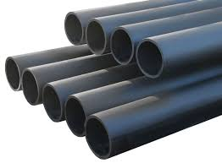 | Washing-up bowls, pipes, chairs, buckets, and bottles | Nontransparent | HDPE is accepted at most recycling centers
Polypropylene (PP) | Lightweight, strong and tough, it has good heat and chemical resistance | 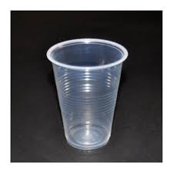 | Reusable containers, flexible packaging, textiles, automotive parts, medical supplies, and toys. | White and translucent in appearance | Recyclable thermoplastic polymer
Polyvinyl Chloride (PVC) | Chemical and weather resistance, low cost, good strength, can be made to be flexible or rigid | 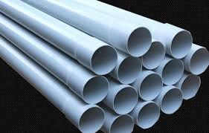 | Piping, blood bags, tubing, wire, and cable insulation | Naturally white | PVC is a type of plastic that is not recyclable
Polyethylene Terephthalate (PET) | Mechanical, thermal, chemical resistance. highly flexible, colorless | 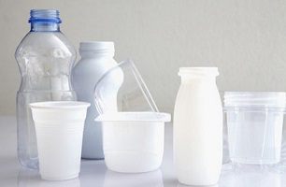 | Packaging, fabrics, films, molded parts for automotive, electronics | Clear easily colored | PET products are 100% recyclable and are the most recycled plastic worldwide.

Thermosetting
Thermosetting polymers are brittle and can only be formed once. They are hard to recycle. They are good insulators and are resistant to heat and chemicals.
Name | Characteristics | Image | Example Use | Appearance | Recyclable
Epoxy Resin (ER) | Strong adhesive, good chemical, and heat resistance. An excellent thermal insulator | 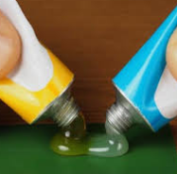 | Bonds materials and can be used for waterproof coatings and lamination | Transparent | No
Melamine Formaldehyde (MF) | Excellent heat resistance, resistant to scratching and staining, hard and strong | 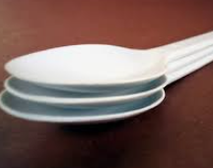 | Laminates for worktops, food-safe | Clear and colorless | No
Phenol Formaldehyde (PF) | Good thermal insulation, low density, and excellent durability | 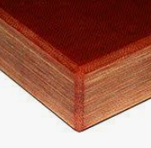 | billiard balls, laboratory countertops, and coatings | Thick reddish-brown material | No
Polyester Resin (PR) | Ease of handling, low cost, dimensional stability, as well as good mechanical, chemical-resistance and electrical properties | 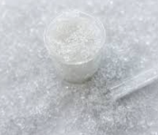 | Sheet moulding compound, bulk moulding compound, and the toner of laser printers | Viscous, pale-colored liquids consisting of a solution of polyester in a monomer which is usually styrene | No
Urea-Formaldehyde (UF) | Hard, stiff, excellent thermal insulation | 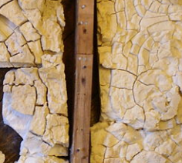 | Electrical fittings, toilet seats. It can be used to create Urea-formaldehyde foam insulation (UFFI) | Nontransparent thermosetting resin or polymer | No

Download
More Key Fact Revision sheets can be downloaded from
www.andrew-seaford.co.uk/revision

Version information
Date | Arthur | Comment
13-Mar-2021 | Andrew Seaford | Initial release.

